Lean-based Lab Experimentation

1.Create a new project and select a company-managed project.

2. Add issue type and description.

3. Add the created issue types to the screens.

4.Now check the custom fields for the issues

5.Choose a field type for the different status.

6.For reference, name the field as Experiment and customize the selection tab.

7. Now create epic and provide the proper summary.

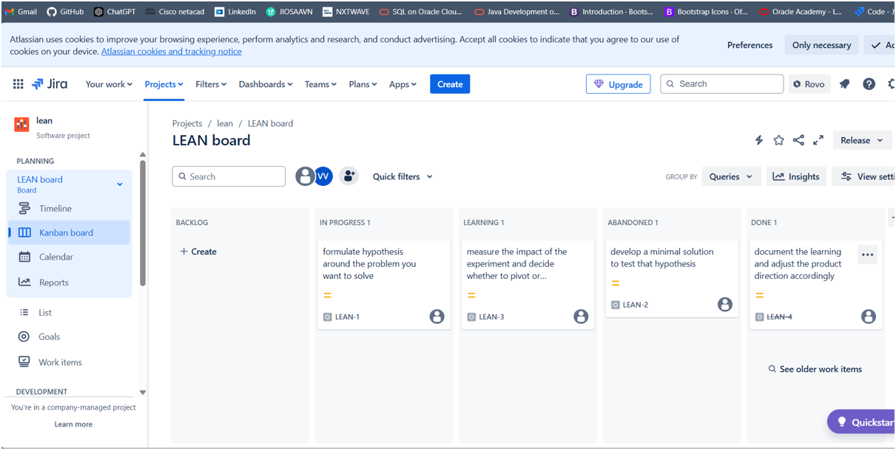

8.Finally check the list of issues in progress, to do and complete state.

